# Fall 2016

2)

Have look at eq (2), p. 427 in book.

3)

2)

3)

2)

Superlinear, and converges as:

You need to differentiate the gradient-function:

$$F^{''}\left(x\right)=f^{'}\left(x\right)=40.49ω^{2}\sin\left(ωx\right)-143.16ω^{2}cos⁡(ωx)$$

x0 = 120;%starting guess

n = 4; %number of iterations

w = (2*pi/360);

x_holder = zeros(numel(n),1);

for i=1:n

f = -40.49*w*cos(w*x0)-143.16*w*sin(w*x0); %define function

df = 40.49*w^2*sin(w*x0)-143.16*w^2*cos(w*x0);

if abs(df)<eps %smaller than machine epsilon to prevent underflow

error("small derivative");

end

d = f/df; %calculate fraction

x0 = x0-d; %calculate new root

x_holder(i,1) = x0;

end

found_roots = sprintf('%.0f\n',x_holder)

Yielding

'176

164

164

164

2.1)

Are the formal 2x2 normal equations.   
One can construct the matrix formulation as follows, using the monomialbase $ϕ_{1}=e^{-x},ϕ_{2}=e^{-2x}$

$$A=\left(\begin{matrix}e^{0} & e^{0} \\ e^{-0.5} & e^{-1} \\ e^{-1} & e^{-2} \\ e^{-1.5} & e^{-3} \\ e^{-2} & e^{-4}\end{matrix}\right), c=\left(\begin{aligned}a \\ b\end{aligned}\right),y=\left(\begin{aligned}2.24 \\ 0.80 \\ 0.38 \\ 0.09 \\ 0.06\end{aligned}\right)$$

Giving the normal-equation:

$$A^{T}Ac=A^{T}y$$

The system matrix is

$$A^{T}A=\left(\begin{matrix}A_{:,1}^{2} & A_{:,2}A_{:,1} \\ A_{:,2}A_{:,1} & A_{:,2}^{2}\end{matrix}\right)$$

Which is the same as in the formal normal-equations.   
The right hand side becomes:

$$A^{T}y=\left(\begin{aligned}2.75+0.38e^{-1}+0.06e^{-2} \\ 2.24+0.8e^{-1}+0.38e^{-2}+0.09e^{-3}+0.06e^{-4}\end{aligned}\right)$$

Both values are easily calculated by

lhs = transpose(A)*A

rhs = transpose(A)*y

**2.2)**

A=[exp(0),exp(0);exp(-0.5),exp(-1);exp(-1),exp(-2);exp(-1.5),exp(-3);exp(-2),exp(-4)];

y = [2.24,0.80,0.38,0.09,0.06];

y = y';

c = (A'*A)\(A'*y)

Giving

c = [a;b]=[0.0751;2.1572]

2.3)

The error is

A=[exp(0),exp(0);exp(-0.5),exp(-1);exp(-1),exp(-2);exp(-1.5),exp(-3);exp(-2),exp(-4)];

y = [2.24,0.80,0.38,0.09,0.06];

y = y';

c = (A'*A)\(A'*y);

xx = linspace(0,2,5);

yy = (c(1).*exp(-xx)+c(2).*exp(-2.*xx))'

error = abs(y-yy)

comb_error = sum((y-yy).^2); %%this is squared-error

This yields the output:



Which in significant decimals can be written as:

$$7.73⋅{10}^{-3}, 3.91⋅{10}^{-2},6.04⋅{10}^{-2},3.42⋅{10}^{-2},1.03⋅{10}^{-2}$$

With 2 significant decimal digits.

The only difference between the two methods are the coefficients. In Heun:

$$α=1,β=1,ω_{1}=\frac{1}{2},ω_{2}=\frac{1}{2}$$

In RK variant:

Page 313:

$$x\left(t+h\right)=x\left(t\right)+ω_{1}hf\left(t,x\right)+ω_{2}hf(t+αh,x+βhf\left(t,x\right))$$

The only term needed to change is thus alpha:

$$x\left(t+h\right)=x\left(t\right)+\frac{1}{2}hf\left(t,x\right)+\frac{1}{2}hf\left(t+\frac{1}{2}h,x+\frac{1}{2}hf\left(t,x\right)\right)$$

Which only implies changing $K_{2}$ in line 23 to:

$$K_{2}=dxdt\left(t\left(i+\frac{1}{2}\right),x\left(1,i\right)+h⋅K_{1}\right)$$

And we have the variant.

We need to fullfill:

$$ω_{1}+ω_{2}=1, αω_{2}=\frac{1}{2}, βω_{2}=\frac{1}{2}$$

Second condition is not fulfilled, if one only looks at equation 9.   
Lets have a look at eq. 7 vs. eq 8:

$$\left(7\right): x\left(t+h\right)=x\left(t\right)+\left(ω_{1}+ω_{2}\right)hf+αω_{2}h^{2}f_{t}+βω_{2}h^{2}ff_{x}$$

$$\left(8\right): x\left(t+h\right)=x+hf+\frac{1}{2}h^{2}f_{t}+\frac{1}{2}h^{2}ff_{x}$$

>>shows that we do miss-hit the first -term.

Using the same two equations:

$$\left(7\right): x\left(t+h\right)=x\left(t\right)+\left(ω_{1}+ω_{2}\right)hf+αω_{2}h^{2}f_{t}+βω_{2}h^{2}ff_{x}$$

$$\left(8\right): x\left(t+h\right)=x+hf+\frac{1}{2}h^{2}f_{t}+\frac{1}{2}h^{2}ff_{x}$$

We know, that the function $f(t,x)$ is independent on t as $x^{'}\left(t\right)=f\left(x\right)=f_{x}$, which implies that $f^{'}\left(t\right)=0$, we can substitute $f_{t}$ by $0$:

$$⟺x\left(t+h\right)=x\left(t\right)+\left(ω_{1}+ω_{2}\right)hf+αω_{2}h^{2}0+βω_{2}h^{2}ff_{x}$$

In our situation giving:

$$x\left(t+h\right)=x\left(t\right)+hf+\frac{1}{2}⋅\frac{1}{2}h^{2}0+1⋅\frac{1}{2}h^{2}ff_{x}=x\left(t\right)+hf+\frac{1}{2}h^{2}ff_{x}$$

Which is completely the same as the taylor-expansion if $f_{t}$ is set to 0:

$$x\left(t+h\right)=x\left(t\right)+\left(ω_{1}+ω_{2}\right)hf+αω_{2}h^{2}0+βω_{2}h^{2}ff_{x}=x\left(t\right)+hf+\frac{1}{2}h^{2}ff_{x}$$

Thus, they match up to and including .

Same exercise:

$$\left(7\right): x\left(t+h\right)=x\left(t\right)+\left(ω_{1}+ω_{2}\right)hf+αω_{2}h^{2}f_{t}+βω_{2}h^{2}ff_{x}$$

$$\left(8\right): x\left(t+h\right)=x+hf+\frac{1}{2}h^{2}f_{t}+\frac{1}{2}h^{2}ff_{x}$$

We know, that the function $g(t,x)$ is independent on x as $x^{'}\left(t\right)=g(t)=f_{t}$, which implies that $f^{'}\left(x\right)=0$, we can substitute $f_{x}$ by $0$:

$$⟺x\left(t+h\right)=x\left(t\right)+\left(ω_{1}+ω_{2}\right)hf+αω_{2}h^{2}f_{t}+βω_{2}h^{2}f⋅0=x\left(t\right)+\left(ω_{1}+ω_{2}\right)hf+\frac{1}{2}⋅\frac{1}{2}h^{2}f_{t}$$

Which obviously only is a valid approximation up to the $h$’th term, as there is a discrepancy in the second term, as the Taylor expansion is:

$$x\left(t+h\right)=x\left(t\right)+hf+\frac{1}{2}h^{2}f_{t}+\frac{1}{2}h^{2}ff_{x}=x\left(t\right)+hf+\frac{1}{2}h^{2}f_{t}$$

Thus, we would undershoot a bit if we were to use higher order terms.

End-point is given as 5.

dxdt =@(t,x)(1/2)*x; %%HUSK TO PARAMETRE SELVOM FUNKTIONEN IKKE ER FUNKTION AF TO PARAMETRE I OPGAVEN

f_analytical = @(t)exp(t/2);

tspan = [0 5];

x0 = 1;

n = [10,20,40,80,160];

x_sol = zeros(numel(n),1);

x_real = f_analytical(5);

for i = 1:5

[t,xf]=RKvariant(dxdt,tspan,x0,n(i));

x_sol(i) = xf(end);

end

Q1absErr = [n;abs(x_real-x_sol)']

Opg 2  
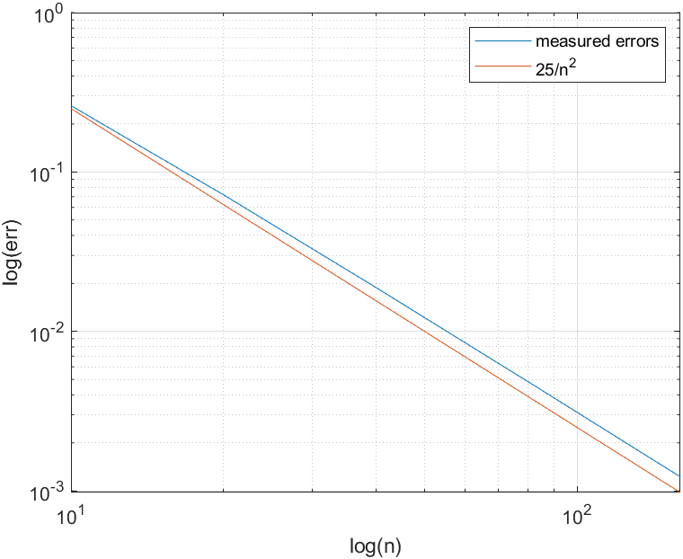

Når den er lineaær og aftagende, så kan vi i hvert fald se, at der er tale om $∝\frac{1}{n^{α}}$.

Man kunne også vise det dovent ved at

Hvilket er *nogenlunde* konstant, hvilket viser at konvergensen er bundet af

Q1absErr =

10.0000 20.0000 40.0000 80.0000 160.0000

0.0945 0.0460 0.0227 0.0113 0.0056



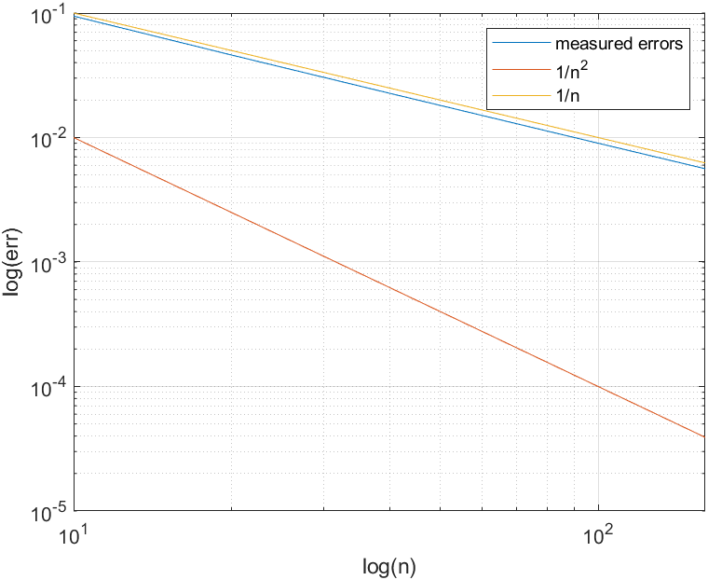

convergence = Q1absErr(2,:).*n

convergence =

0.9454 0.9204 0.9079 0.9017 0.8985

Almost constant – thus converges as .

The vector-2-norm is defined as the Euclidean distance. We can use the worst-case scenario given:

$${\left|\left|δb\right|\right|}_{2}=\sqrt{δ_{1}^{2}+δ_{2}^{2}+…+δ_{n}^{2}}≤\sqrt{{0.005}^{2}+{0.005}^{2}+…+{0.005}^{2}}=\sqrt{100⋅{\left(0.005\right)}^{2}}=10⋅0.005=0.05$$

This exemplifies the general vector-norm-property:



$$\max_{i}{{|x}_{i}|}≤{\left|\left|x\right|\right|}_{2}≤\sqrt{n}\max_{i}\left|x_{i}\right|$$

We have the general matrix-vector property regarding the norm:

$${\left|\left|αx\right|\right|}_{2}=\left|α\right|{\left|\left|x\right|\right|}_{2} and \left\|Ax\right\|≤\left\|A\right\|{\left\|x\right\|}_{2}$$

We have the system:

$$Ax=b$$

$${\left\|b\right\|}_{2}={\left\|Ax\right\|}_{2}≤{\left\|A\right\|}_{2}{\left\|x\right\|}_{2}$$

$$⟺\frac{1}{{\left\|x\right\|}_{2}}≤\frac{{\left\|A\right\|}_{2}}{{\left\|b\right\|}_{2}}$$

We also have for the perturbation in $x$**:**

$$Aδx=A\left(\tilde{x}-x\right)=\tilde{b}-b=δb⟺δx=A^{-1}δb→{\left|\left|δx\right|\right|}_{2}={\left|\left|A^{-1}δb\right|\right|}_{2}$$

We can write the results together, thus obtaining the definition of the relative error:

$$→ \frac{{\left\|δx\right\|}_{2}}{{\left\|x\right\|}_{2}}≤\frac{{\left\|A\right\|}_{2}}{{\left\|b\right\|}_{2}}{\left|\left|A^{-1}δb\right|\right|}_{2}$$

Using the definition of the condition-number:

$$=\frac{{\left\|δx\right\|}_{2}}{{\left\|x\right\|}_{2}}≤κ\left(A\right)\frac{{\left|\left|δb\right|\right|}_{2}}{{\left|\left|b\right|\right|}_{2}}$$

Thus, the upper bound numerically becomes:

$$\frac{{\left\|δx\right\|}_{2}}{{\left\|x\right\|}_{2}}≤2.2⋅\frac{\left(0.05\right)}{1.4}=7.8571⋅{10}^{-2}$$

**Assignment about factorizations**

**1)**

**Jacobian:**

$$J=\left(\frac{∂f}{∂x_{1}} … \frac{∂f}{∂x_{n}}\right)=\left(\begin{matrix}2x_{1} & 2 \\ 1 & 8x_{2}\end{matrix}\right)$$

The matlab-code thus becomes

function [f,dF] = funFdF(X)

%%input are variables, output is function matrix and jacobian matrix for

%%system described in 23.1

f = [X(1)^2+2*X(2)-2;X(1)+4*X(2)^2-4];

dF = [2*X(1),2;1,8*X(2)];

end

**2)   
The Newton-iteration for finding the roots may be written as:**

$$X^{k+1}=X^{k}-J{\left(X^{\left(k\right)}\right)}^{-1}F\left(X^{\left(k\right)}\right)$$

Finding the inverse of the jacobian is numerically very unstable, and also a very slow operation. Thus, we rewrite, as the Taylor-expansion gives us:

$$0≈F\left(X^{0}+H\right)≈F\left(X^{0}\right)+F^{'}\left(X^{0}\right)H$$

Which means that we can find the solution to the Jacobian Linear System: $$\left(J\left(X^{(k)}\right)\right)H^{(k)}=-F\left(X^{\left(k\right)}\right)⟺H^{\left(k\right)}=-J{\left(X^{\left(k\right)}\right)}^{-1}F\left(X^{\left(k\right)}\right)$$

Which is the same as finding the solution to the system $-J\left(X^{\left(k\right)}\right)F\left(X^{\left(k\right)}\right)$**, ie. $-H^{\left(k\right)}J\left(X^{\left(k\right)}\right)=F\left(X^{\left(k\right)}\right)$**

This yields the inverse of the Jacobian with numerical stability. This is implemented using mldivide \. The final iteration thus becomes (by substitution of H):

$$X^{k+1}=X^{\left(k\right)}+H^{\left(k\right)}$$

**3) Implementing the iteration:**

1. Finding goal values of iteration 1:

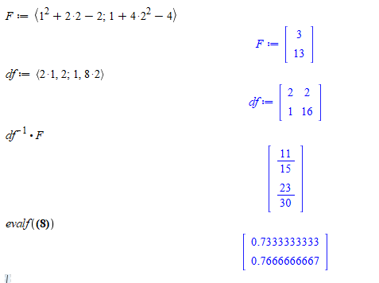

This implementation seems fit:



Giving the results:

4)   
Including the errors in the implementation. It is important to remember, that we are working with vector-norms, ie no abs error.



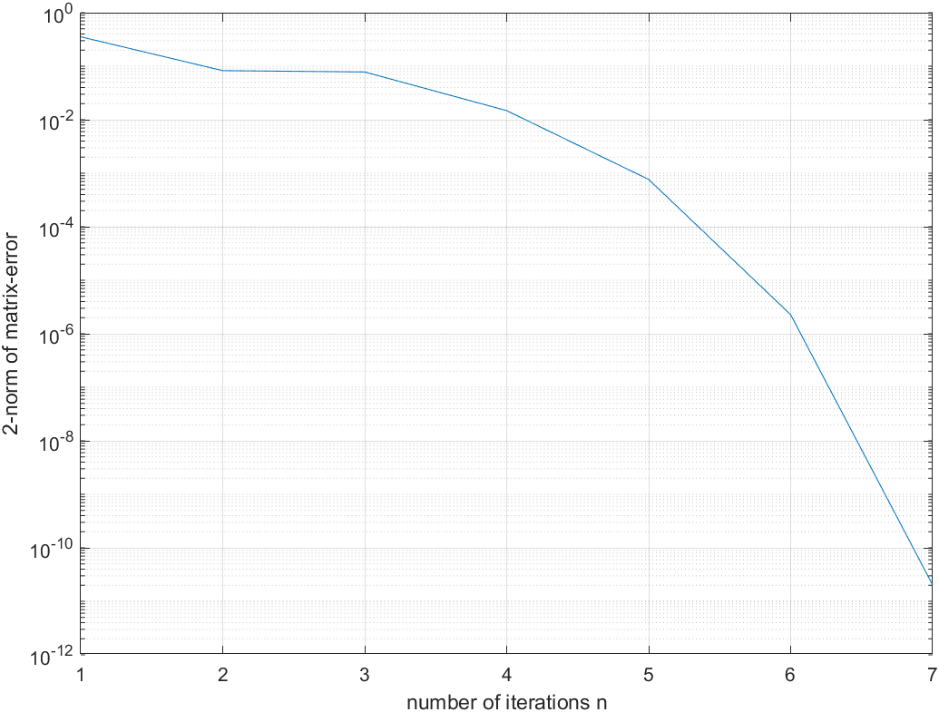

1)   
It must be completely real, symmetric, and positive definite. Symmetric means $A=A^{T}$. Positive definite means that all eigenvalues are positive – but more properties do describe positive definitiveness.

2)   
The Cholesky factorization itself uses for the outer loop:   
For each $i=k$ er der $k-1$ multiplikationer (da $k=1$ ikke giver nogen multiplication), og $k=1:n$. Det giver samlet set: $$\sum_{k=1}^{n}{\left(k-1\right)}=n⋅\frac{n-1}{2}$$

Multiplikationer og divisioner i yderløkken (du kan beregne den variable sum med maple, EZ-PZ). Endvidere er der $n$ rødder og subtraktioner.   
I inderløkken har du principielt set samme arbejdsbyrde, men det skal ganges med yderløkken:

Multiplikationer:

$$\left(n⋅\frac{n-1}{2}\right)⋅\frac{n}{3}$$

Og det samme for subtraktionerne. $1/3$ ved jeg ikke rigtigt, hvor kommer fra.   
Det giver dog samlet set den dominante term $$\frac{n^{3}-n}{6}$$

Hvilket tidsmæssigt er $O(n^{3})$.

Strategi 1 ville så have:

$$O_{1}=\left(\frac{n^{3}-n}{6}\right)+n^{3}=\frac{7}{6}n^{3}-\frac{1}{6}n$$

Strategi 2 ville kun kræve $\frac{n^{3}}{2}$ i tillæg for at beregne $L^{2}$, da det er en lower-triangular, hvilket vil sige at den maksimalt har $\frac{n}{2}$ elementer:

$$O_{2}=\left(\frac{n^{3}-n}{6}\right)+{\frac{n}{2}}^{3}=\frac{7}{24}n^{3}-\frac{1}{6}n$$

Hvilket er en del mindre. De er dog begge .

It is given that it is symmetric, and thus we may apply LU-factorization.

|  |  |
| --- | --- |
| $$A=LU$$ | (1) |
| $$MA≡U$$ | (2) |
| $$→U=\left(\begin{matrix}2 & 1 \\ 0 & 2\end{matrix}\right)$$ | (2) |

Now, we wish to solve:

$$LU=A=\left(\begin{matrix}l_{11} & 0 \\ l_{21} & l_{22}\end{matrix}\right)\left(\begin{matrix}2 & 1 \\ 0 & 2\end{matrix}\right)=\left(\begin{matrix}2 & 1 \\ 1 & 2\end{matrix}\right)$$

First we find $l_{11}$ (for using fwd-sub)

$$2l_{11}=2→l_{11}=1$$

Next row:

$$2l_{21}=1, l_{21}+2l_{22}=2$$

$$⟺l_{21}=\frac{1}{2}, l_{22}=\frac{3}{4}$$

Thus, the factorization becomes:

$$LU=\left(\begin{matrix}1 & 0 \\ 1/2 & 3/4\end{matrix}\right)\left(\begin{matrix}2 & 1 \\ 0 & 2\end{matrix}\right)=\left(\begin{matrix}2 & 1 \\ 1 & 2\end{matrix}\right)$$

Which shows, that it is a valid factorization. Unlimited many other factorizations exist aswell, though.

**2) Check if you can use LDL factorization $A$** is symmetric and positive definitive (eigenvalues 3,1). Thus, a $LDL^{T}$-factorization must exist.

Sadly, I made a Crout-factorization before for doing LU. LU factorization using Doolittle:

$$LU=A=\left(\begin{matrix}1 & 0 \\ l_{21} & 1\end{matrix}\right)\left(\begin{matrix}u_{11} & u_{12} \\ 0 & u_{22}\end{matrix}\right)=\left(\begin{matrix}2 & 1 \\ 1 & 2\end{matrix}\right)$$

$$u_{11}=2 \\ u_{12}=1$$

$$l_{21}u_{11}=2→l_{21}=\frac{1}{2}$$

$$l_{21}u_{12}+u_{22}=\frac{1}{2}+u_{22}=2→u_{22}=\frac{3}{2}$$

$$U=\left(\begin{matrix}2 & 1 \\ 0 & 3/2\end{matrix}\right) \\ L=\left(\begin{matrix}1 & 0 \\ 1/2 & 1\end{matrix}\right)$$

Applying LDLT-factorization using the unit lower triangular:

$$LU=A=A^{T}=U^{T}L^{T}$$

Extract diagonal elements from U and putting into D and writing transpose L:

$$U=DL^{T}=\left(\begin{matrix}2 & 0 \\ 0 & \frac{3}{2}\end{matrix}\right)\left(\begin{matrix}1 & 1/2 \\ 0 & 1\end{matrix}\right)=DL^{T}$$

(Which is the same mathematically as finding the solution to):

$$D=U{\left(L^{T}\right)}^{-1}=\left(\begin{matrix}2 & 1 \\ 0 & 3/2\end{matrix}\right)⋅\left(\begin{matrix}1 & -\frac{1}{2} \\ 0 & 1\end{matrix}\right)=\left(\begin{matrix}2 & 0 \\ 0 & 3/2\end{matrix}\right)$$

Thus, we have:

$$A=LDL^{T}=\left(\begin{matrix}1 & 0 \\ 1/2 & 1\end{matrix}\right)\left(\begin{matrix}2 & 0 \\ 0 & \frac{3}{2}\end{matrix}\right)\left(\begin{matrix}1 & 1/2 \\ 0 & 1\end{matrix}\right)=\left(\begin{matrix}2 & 1 \\ 1 & 2\end{matrix}\right)$$

Which shows, that $A$ has a $LDL$-factorization.



We know it is positive definitive, and symmetric. Thus, it must have a Cholesky factorization. $$A=LDL^{T}⟺A=\tilde{L}{\tilde{L}}^{T}, \tilde{L}≡LD^{1/2}$$

Thus, we simply need take the squareroot of earlier found D:

$$\tilde{L}=L\left(\begin{matrix}\sqrt{2} & 0 \\ 0 & \sqrt{\frac{3}{2}}\end{matrix}\right)$$

Giving us:

With .

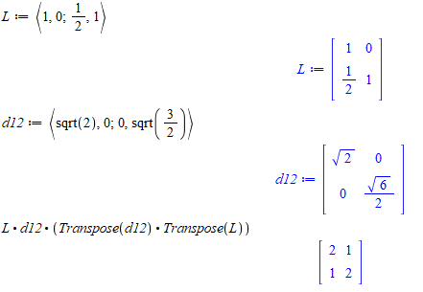

from the definition of the Euclidean norm:

$${\left|\left|δb\right|\right|}_{2}=\sqrt{δb_{1}^{2}+δb_{2}^{2}+…δb_{n}^{2}}$$

We know that the maximal error is $0.001$, and thus this 2-norm is our upper-bound:

$→$ $${\left|\left|δb\right|\right|}_{2}≤\sqrt{{0.001}^{2}+{0.001}^{2}+…{0.001}^{2}}$$

We have the value $n$ times, and we know that $\sqrt{a^{2}+a^{2}}=\sqrt{2a^{2}}=\sqrt{na^{2}}=\sqrt{n}a$. Thus we may write

$${\left|\left|δb\right|\right|}_{2}≤\sqrt{{0.001}^{2}+{0.001}^{2}+…{0.001}^{2}}=\sqrt{n⋅{0.001}^{2}}=\sqrt{n}⋅0.001$$

The upper bound of the relative error may be found using the newly identified upper bound for the norm of the measurement-matrix. We want to figure out:

$$A\left(x+δx\right)=Ax+Aδx=b+δb$$

We know from properties of vector-norms that:

$$\left|\left|Ax\right|\right|≤\left|\left|A\right|\right| \left|\left|x\right|\right|$$

Which means we may write:

$$\left|\left|b\right|\right|=\left|\left|Ax\right|\right|≤\left|\left|A\right|\right| \left|\left|x\right|\right|$$

Yielding

$$⟺\frac{1}{\left|\left|x\right|\right|}≤\frac{\left|\left|A\right|\right|}{\left|\left|b\right|\right|}$$

Introducing the perturbation in b:

$$Aδx=δb→\left|\left|δx\right|\right|≤\left|\left|δb\right|\right| \left|\left|A^{-1}\right|\right|$$

Thus we can write the relative error:

$$\left|\left|δx\right|\right|\frac{1}{\left|\left|x\right|\right|}≤\left|\left|δb\right|\right| \left|\left|A^{-1}\right|\right|\frac{\left|\left|A\right|\right|}{\left|\left|b\right|\right|}=κ(A)\frac{\left|\left|δb\right|\right|}{\left|\left|b\right|\right|}$$

Thus, we have all information for finding a value for the upper bound of the relative error:

$$\frac{\left|\left|δx\right|\right|}{\left|\left|x\right|\right|}≤3.8⋅\frac{\sqrt{100}⋅0.001}{1.7}=2.2⋅{10}^{-2}$$

With two significant digits.

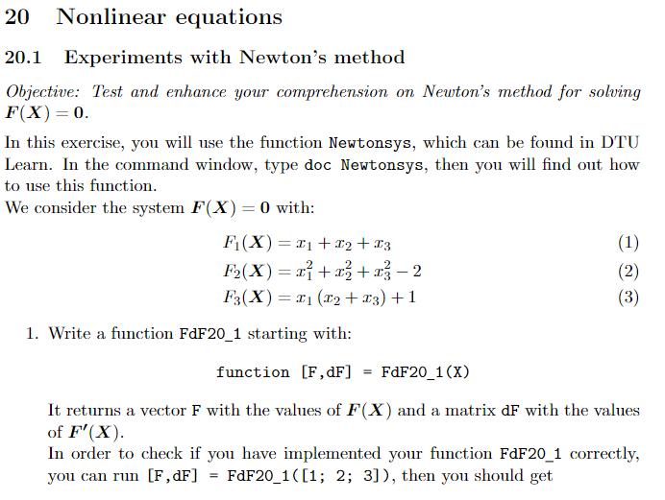

X0 = [3/4;1/2;-1/2];

n = 10;

X = X0;

Xiter = zeros(n,numel(X));

for i=1:n %%newton method

[F,dF] = FdF20_1(X);

H = dF\F;

X = X-H;

Xiter(i,:) = X;

end

plot(Xiter)

function [F,dF] = FdF20_1(X)

F = [X(1)+X(2)+X(3);X(1)^2+X(2)^2+X(3)^2-2;X(1)*(X(2)+X(3))+1];

dF = [1,1,1;2*X(1),2*X(2),2*X(3);X(2)+X(3),X(1),X(1)];

end

is the function.

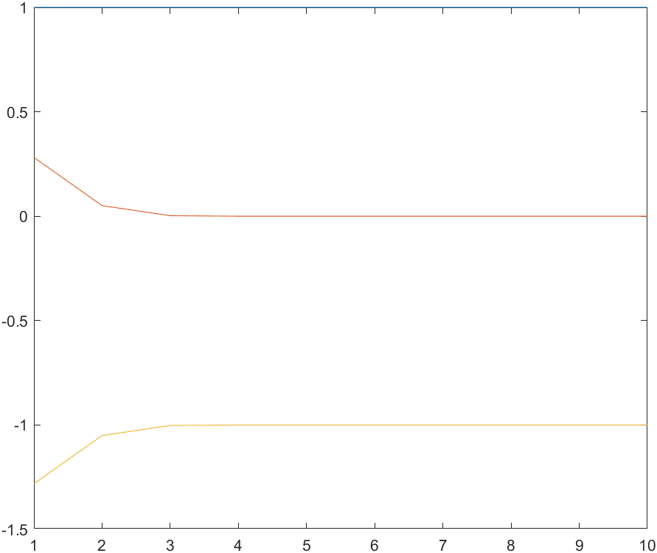

Converges to $X^{(10)}=\left(\begin{aligned}1 \\ 0 \\ -1\end{aligned}\right)$



We get

$$F\left(X\right)=\left(\begin{aligned}1.75 \\ -0.9375 \\ 1.50\end{aligned}\right)$$

And $$J\left(X\right)=\left(\begin{matrix}1 & 1 & 1 \\ 3/2 & 1 & 1 \\ 1 & 3/4 & 3/4\end{matrix}\right)$$

Finding $H$ for the first iteration:

$$H=-J{\left(X\right)}^{-1}F(X)$$

Solving this system gives us problems. Why? Because the Jacobian is singular: $$Det\left(J(X)\right)=0$$

Which means that it does not have an inverse matrix (this would be the same as dividing by zero). Thus, Newtons method fails for this system, as it is based on the Jacobian being non-singular.

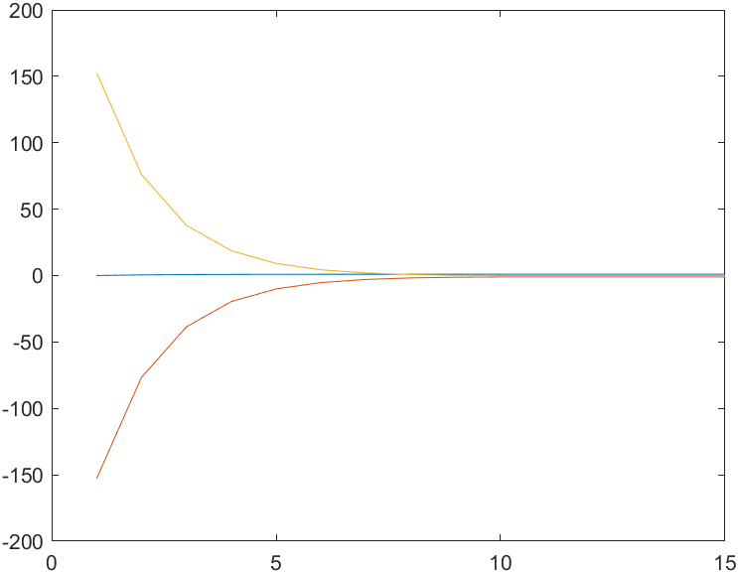

Converges towards:

Building upon earlier code:

%%error-assesment

%error-assesment

err = zeros(n,1);

for k=1:n %%newton method

err(k) = max(abs(Xiterations(:,end)-Xiterations(:,k)));

end

figure(2)

semilogy(1:n-1,err(1:end-1));

grid('on')

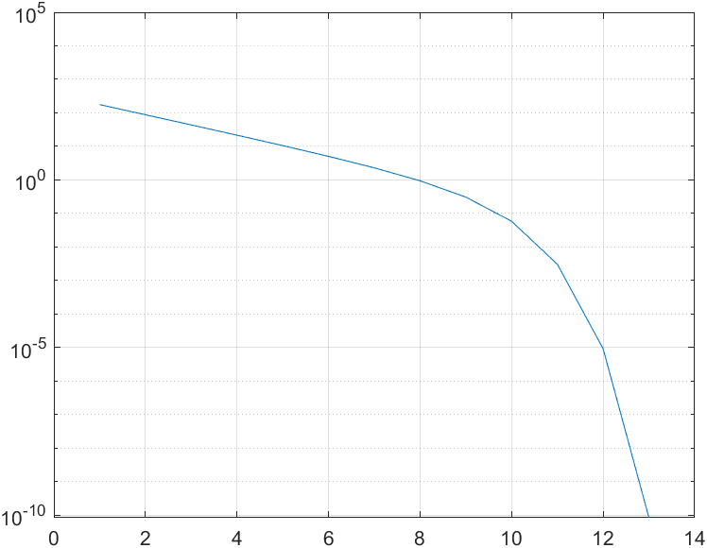

Shows that we dip beyond 10e-6 at 13 iterations.

Finding the Jacobian using Maple as it is quite large. Notice it is only a function of xy

Debugger ved at sidetjekke med Maple og bruge subs.

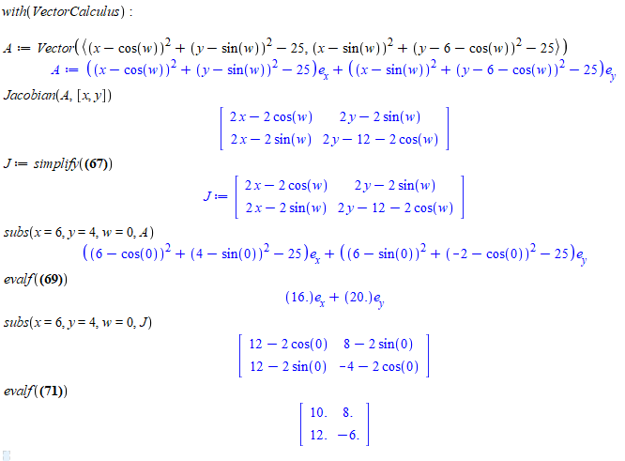

Det spiller.

2)

X0 = [2,2]';

FdF = @(X) FdF20_2(X,0);

Xiter = Newtonsys_facit(FdF,X0,5);

for i = 1:5

err(i) = norm(4-Xiter(:,i));

end

Which shows us, that the implementation is fine, we get $X^{(5)}≈\left(\begin{aligned}4 \\ 4\end{aligned}\right)$ and need 4 iterations to dip under ${10}^{-3}$ distance from $\left(\begin{aligned}4 \\ 4\end{aligned}\right)$.

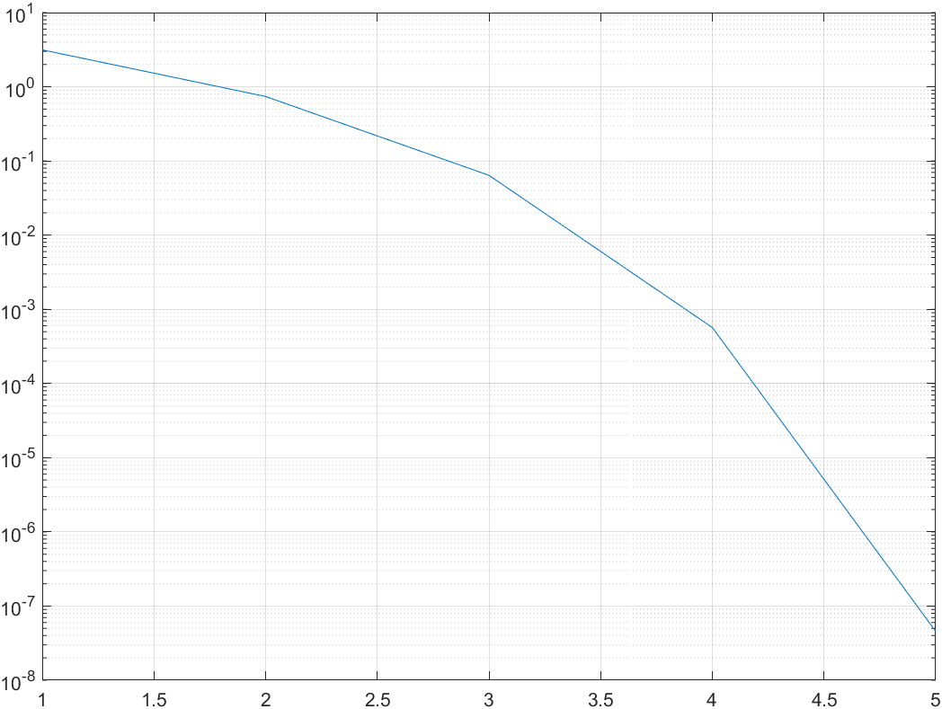

3)

The following code is implemented:

X0 = [2,2]';

FdF = @(X) FdF20_2(X,0);

Xiter = Newtonsys_facit(FdF,X0,5);

%Q3

omega = linspace(0,2*pi,361);

X0 = Xiter(:,4); %numerical solution to omega = 0 ie first point with error smaller than 10e-3. Thus very nice start-guess -> only one iteration needed for every point

position = zeros(2,numel(omega)-1); %placeholder for rest of solutions

position(:,1) = X0; %%first point has been calculated

for i=2:numel(omega) %thus no need for omega(1)=0.

FdF = @(X) FdF20_2(X,omega(i)); %generate function-handle for new root-guess and omega-value

k = 2;

Xiter = Newtonsys_facit(FdF,position(:,i-1),k); %save results in 2x361 matrix with format [x;y]. Use last found position

position(:,i) = Xiter(:,end);

%%X = position(:,i); %overwrite root-guess

end

plot(position(1,:),position(2,:)) %parametrized plot for P3 = (x,y)

title('P_3(\omega)')

xlabel('x-val')

ylabel('y-val')

%Q4 distance calculation

Xanalytical = [4;4];

dist = norm(Xanalytical-position(:,end));

Which gives us:

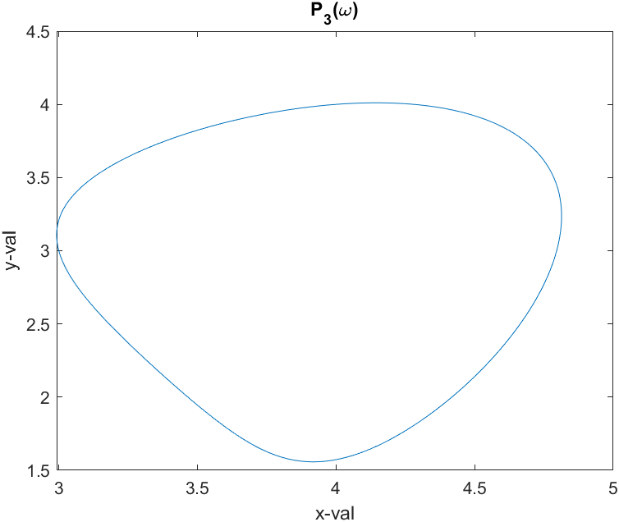

4)

The distance is easily found:

%Q4 distance calculation

Xanalytical = [4;4];

dist = norm(Xanalytical-position(:,end));

Giving $5.54⋅{10}^{-5}$.



In the grand scheme the plots look the same. The distance, though, is only $4.4⋅{10}^{-10}$ ie way better.

2) which is the same as solving $A\backslash b$ for $w$:

A = [3,12,10;12,0,20;0,2,30];

b = [72.3;99.5;56.6];

weights = A\b

Which gives us

3) System with perturbation gives $\tilde{w}=\left(\begin{aligned}5.4 \\ 3.4 \\ 1.7\end{aligned}\right)$



A = [3,12,10;12,0,20;0,2,30];

b = [72.3;99.5;56.6];

b_err = [73.3;98.4;57.1];

weights_err = A\b_err

weights = A\b;

abs_err = abs(weights-weights_err)

[val,worst_element] = max(abs_err)

Gives us abserr:

$$e_{abs}=\left(\begin{aligned}1.1⋅{10}^{-2} \\ 1.0⋅{10}^{-2} \\ 9.9⋅{10}^{-3}\end{aligned}\right)$$

With worst error-contributor being screws.

rel_rhs = norm(b_err-b)/norm(b)

rel_lhs = norm(weights_err-weights)/norm(weights)

kappa = cond(A)

rel_rhs =

1.1584e-02

rel_lhs =

2.2536e-02

kappa =

3.9080e+00

Theoretical upper bound for error is thus:

$$\frac{\left|\left|δx\right|\right|}{|\left|x\right||}≤κ\left(A\right)\frac{\left|\left|δb\right|\right|}{\left|\left|b\right|\right|}=3.91⋅\frac{\left|\left|\tilde{b}-b\right|\right|}{\left|\left|b\right|\right|}=3.91⋅1.16⋅{10}^{-2}=4.53⋅{10}^{-2}$$

Thus, the actual measured relative error:

$$\frac{\left|\left|δx\right|\right|}{|\left|x\right||}=(2.25⋅{10}^{-2})$$

Is almost exactly half the size of the upper bound.

We know for Matrix-norms:

$$\left|\left|\tilde{X}\right|\right|=\left|\left|A^{-1}\tilde{B}A^{-1}\right|\right|≤\left|\left|A^{-1}\right|\right| \left|\left|\tilde{B}\right|\right| \left|\left|A^{-1}\right|\right|$$

We also have

$$\left|\left|X\right|\right|=\left|\left|A^{-1}BA^{-1}\right|\right|≤\left|\left|A^{-1}\right|\right| \left|\left|B\right|\right| \left|\left|A^{-1}\right|\right|⟺\frac{1}{\left|\left|X\right|\right|}≤\left|\left|A\right|\right| \left|\left|B^{-1}\right|\right| |\left|A\right||$$

Thus, the fraction becomes:

$$\frac{\left|\left|\tilde{X}\right|\right|}{\left|\left|X\right|\right|}≤\left|\left|A\right|\right| \left|\left|B^{-1}\right|\right| \left|\left|A\right|\right|\left|\left|A^{-1}\right|\right| \left|\left|\tilde{B}\right|\right| \left|\left|A^{-1}\right|\right|$$

Remember that these are norms, thus numbers and no longer matrices. Thus, we have commutative multiplication:

$$⟺\frac{\left|\left|\tilde{X}\right|\right|}{\left|\left|X\right|\right|}≤\left|\left|A\right|\right| \left|\left|A^{-1}\right|\right|\left|\left|A\right|\right| \left|\left|A^{-1}\right|\right|\left|\left|\tilde{B}\right|\right| \left|\left|B^{-1}\right|\right|≤κ{\left(A\right)}^{2}\frac{|\left|\tilde{B}\right||}{|\left|B\right||}$$

The division between B’s is only possible as $$\left|B^{-1}\right|≥{\left|B\right|}^{-1}$$

Which makes this an upper bound to the whole error-propagation.

Which we were requested to show.   
It needs to be noted that we use one specific property for $B$:

$$\left|B^{-1}\right|≥{\left|B\right|}^{-1}$$

Which makes us able to do the division.

We wish the upper bound to be 0.02.   
We can easily find condition-number of our matrix A. Thus, we simply isolate:

$$0.02<κ{\left(A\right)}^{2}\frac{|\left|\tilde{B}\right||}{|\left|B\right||}⟺\frac{0.02}{κ{\left(A\right)}^{2}}\left|\left|B\right|\right|>\left|\left|\tilde{B}\right|\right|$$

$$→\left|\left|\tilde{B}\right|\right|<3.05⋅{10}^{3}$$

Which seems a bit large.

We make random matrix and designate nE=norm(E). Thus, we now know:

$$\left|\left|αδB\right|\right|≤3.05⋅{10}^{3}⟺α\left|\left|δB\right|\right|≤3.05⋅{10}^{3}$$

Thus, we need to rescale our random noisy-matrix:

$$\left|\left|E\right|\right|=3.433⋅{10}^{1}⋅α=3.05⋅{10}^{3}$$

$$⟺{\left(\frac{3.433⋅{10}^{1}}{3.05⋅{10}^{3}}\right)}^{-1}=α$$

Thus, we scale $E$ by this factor, and then add $B+E$:

X2 = A\(B+E)/A;

figure(2)

imagesc(X2), axis image off, colormap gray

rel_error = norm(X-X2)/norm(X);

Which gives us the relative error $6⋅{10}^{-3}=0.006$, which is way smaller than the upper bound.

Whole script:

load deblur.mat %%import matrix-data

[L,U,P] = lu(A);

X = U\(L\B/U)/L;

figure(1)

imagesc(X), axis image off, colormap gray

faxi_condi = cond(A);

blurring_boundary = (0.02/(faxi_condi^2))*norm(B);

E = randn(size(A));

nE = norm(E);

E = E*blurring_boundary/nE;

nE = norm(E);

X2 = A\(B+E)/A;

figure(2)

imagesc(X2), axis image off, colormap gray

rel_error = norm(X-X2)/norm(X);



Different for each run, but in general \ is a bit faster. Determinant-time is in general one to two orders of magnitude slower. At n=800, \ is almost twice as quick as inv time, and ${10}^{2}⋅5.6=560$ times faster than determinant-method.

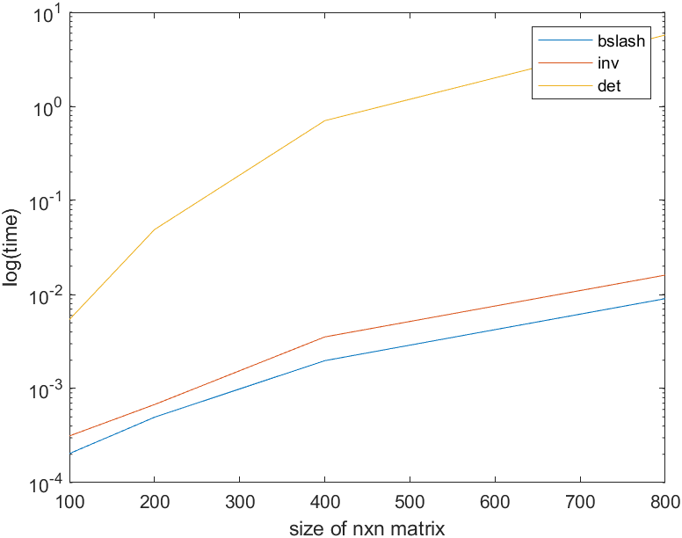

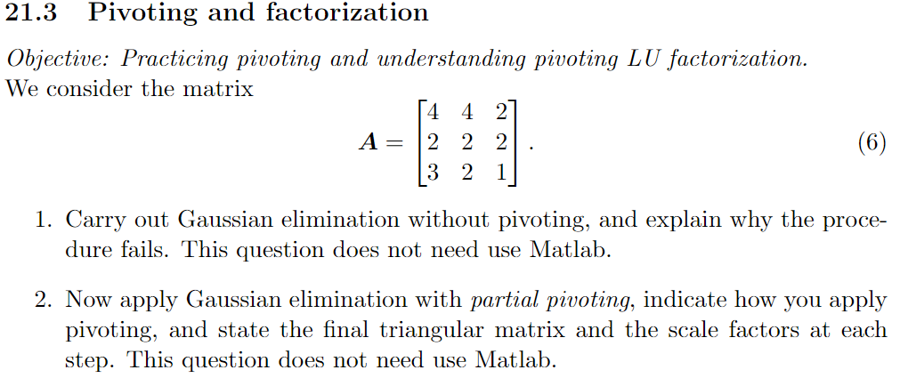

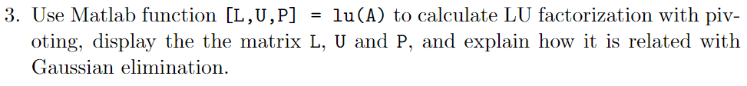

1) $$A=\left(\begin{matrix}1 & 1 & 1/2 \\ 1 & 1 & 1 \\ 3 & 2 & 1\end{matrix}\right)⟺\left(\begin{matrix}1 & 1 & \frac{1}{2} \\ 0 & 0 & \frac{1}{2} \\ 0 & -1 & -\frac{1}{2}\end{matrix}\right)⟺\left(\begin{matrix}1 & 0 & 0 \\ 0 & 1 & 1 \\ 0 & -1 & -\frac{1}{2}\end{matrix}\right)⟺\left(\begin{matrix}1 & 0 & 0 \\ 0 & 1 & 1 \\ 0 & 1 & 1\end{matrix}\right)$$

Which clearly shows, that we are not able to carry out the elimination without pivoting until the end. Gauss-elimination is the same as doing a Doolittle LU-factorization:

$$A=LU=\left(\begin{matrix}1 & 0 & 0 \\ l_{21} & 1 & 0 \\ l_{31} & l_{32} & 1\end{matrix}\right)\left(\begin{matrix}4 & 4 & 2 \\ 0 & u_{22} & u_{23} \\ 0 & 0 & u_{33}\end{matrix}\right)=\left(\begin{matrix}4 & 4 & 2 \\ 2 & 2 & 2 \\ 3 & 2 & 2\end{matrix}\right)$$

Thus, we know that:

$$4l_{21}+1⋅0+0=2⟺l_{21}=1/2 \\ 4l_{21}+u_{22}=2⟺u_{22}=0 \\ 2l_{21}+u_{23}=2⟺u_{23}=0$$

Which means we can calculate the last row:

$${4l}_{31}+0l_{32}+1⋅0=3⟺l_{31}=\frac{3}{4}$$

$$4l_{31}+u_{22}l_{32}+0=2⟺u_{22}l_{32}=2-4l_{31}=2-\frac{3}{4}=\frac{5}{8}$$

$$⟺l_{32}=\frac{\frac{5}{8}}{u_{22}}$$

Hvilket ikke kan lade sig give sig, da $u_{22}=0$. Derfor fejler metoden altså, og systemet kan ikke LU-faktoriseres.

We are simply unable to get a solution. This was in effort of trying to get the reduced row echelon form. I could instead try and get an upper triangular (echelon form):

$$=\left(\begin{matrix}1 & 1 & 1/2 \\ 1 & 1 & 1 \\ 3 & 2 & 1\end{matrix}\right)⟺\left(\begin{matrix}1 & 1 & \frac{1}{2} \\ 0 & 0 & \frac{1}{2} \\ 0 & -1 & -\frac{1}{2}\end{matrix}\right)⟺(rowsubs)\left(\begin{matrix}1 & 1 & \frac{1}{2} \\ 0 & -1 & -\frac{1}{2} \\ 0 & 0 & \frac{1}{2}\end{matrix}\right)$$

Which is doable if one uses pivoting (which is the row-substitution between 2nd and 3rd row).

In LU-factorization terms this would be equivalent to finding a factorization to the system:

$$A=LU=\left(\begin{matrix}1 & 0 & 0 \\ l_{21} & 1 & 0 \\ l_{31} & l_{32} & 1\end{matrix}\right)\left(\begin{matrix}4 & 4 & 2 \\ 0 & u_{22} & u_{23} \\ 0 & 0 & u_{33}\end{matrix}\right)=\left(\begin{matrix}4 & 4 & 2 \\ 3 & 2 & 2 \\ 2 & 2 & 2\end{matrix}\right)$$

Which now gives:

$$4l_{21}+0=3⟺l_{21}=\frac{3}{4}$$

$$4l_{21}+u_{22}=2→u_{22}=-1$$

$$2l_{21}+u_{23}=2⟺u_{23}=2-\frac{6}{4}=1/2$$

Accordingly for the last row:

$$4l_{31}=2→l_{31}=1/2$$

$$4l_{31}+l_{32}u_{22}=2=2+l_{32}\left(-1\right)⟺l_{32}=0$$

$$2l_{31}+l_{32}u_{23}+u_{33}=2=1+0+u_{33}⟺u_{33}=2-1=1$$

And thus the system could be factored:

$$LU=\left(\begin{matrix}1 & 0 & 0 \\ 3/4 & 1 & 0 \\ 1/2 & 0 & 1\end{matrix}\right)\left(\begin{matrix}4 & 4 & 2 \\ 0 & -1 & 1/2 \\ 0 & 0 & 1\end{matrix}\right)=\left(\begin{matrix}4 & 4 & 2 \\ 3 & 2 & 2 \\ 2 & 2 & 2\end{matrix}\right)$$

Therefore, using partial pivoting makes it possible. Writing the pivoting-operation in matrix-form:

$$P_{1}=\left(\begin{matrix}1 & 0 & 0 \\ 0 & 0 & 1 \\ 0 & 1 & 0\end{matrix}\right)$$

$$A_{1}=P_{1}A=\left(\begin{matrix}4 & 4 & 2 \\ 3 & 2 & 2 \\ 2 & 2 & 2\end{matrix}\right)$$

Reducing first column using $M_{1}:$

$$M_{1}=\left(\begin{matrix}1 & 0 & 0 \\ -3/4 & 1 & 0 \\ -2/4 & 0 & 1\end{matrix}\right)→M_{1}A_{1}=\left(\begin{matrix}4 & 4 & 2 \\ 0 & -1 & -1/2 \\ 0 & 0 & 1\end{matrix}\right)$$

Which thus is in triangular (echelon) form. Thus, the elimination has succeeded.

We see:

And

$$L=M_{1}^{-1}$$

Thus, it is the same operation in opposite direction 😊

1)   
So we should use different interpolation forms from 0-degree polynomial up to n-1-degree polynomial.

2)

n = [1:12];

for i=n

v = linspace(0,1,i);

M = vander(v);

condition_number(i) = cond(M);

end

semilogy(n,condition_number);

%%datafitting part

A = [n',ones(numel(n),1)];

logC = log10(condition_number');

c = (A'*A)\(A'*logC)

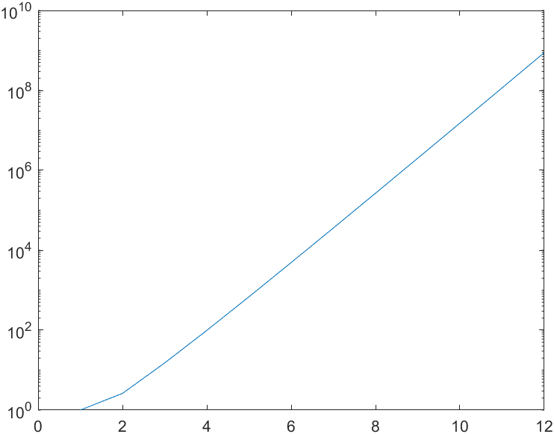

3)   
Yes, the Vandermonde matrix is defined as the coefficient matrix $A$, and thus $A^{T}A=M^{T}M$, which is the definition of the system matrix.

4)

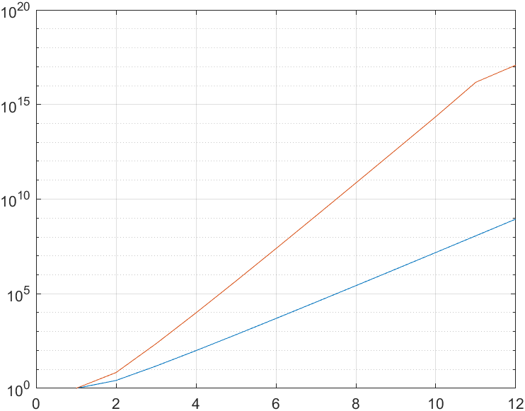

It seems that $d_{n}≈c_{n}^{2}$

5)

1.0000e+00

2.6180e+00

1.5100e+01

9.8868e+01

6.8643e+02

4.9244e+03

3.6061e+04

2.6782e+05

2.0094e+06

1.5193e+07

1.1558e+08

8.8348e+08

Thus, we in the end expect to loose 8 significant digits -> 15-8 = 7 sig.dig. left when solving the linear system.   
In the normal equation, we expect to loose approximately ${\left({10}^{8}\right)}^{2}={10}^{16}→k=16$ digits ie we have overflow. At $n=10$ we only have $1$ significant digit left when doing the data-fitting (solving the normal-equation).

1) All eigenvalues are real and positive.

2)   
Siden at B er symmetrisk, så: $B=B^{T}$, hvorved at

$$\det{(B^{T}}-λI)=det⁡(B-λI)$$

Hvilket betyder, at egenvektoren for de to submatricer må være ens. Siden at hver undermatrix er symmetrisk, er produktet det nødvændigvis også, og det opfylder betingelsen af at have samme linearitet som matricen $B$, dvs. det er blot en skalering af $B$. Herfor kommer der til at stå:

3)   
Vi ved nu, at $v$ er egenvektor til B med eigenværdi $λ$, og egenvektor til $B^{T}B$ med værdi $λ^{2}$. Herved ved vi, at to-normen ${\left|\left|M\right|\right|}_{2}=\sqrt{λ_{max}}=\sqrt{σ}$

Endvidere ved vi at ${\left|\left|M^{T}M\right|\right|}_{2}=\sqrt{λ_{max}^{2}}=\sqrt{σ^{2}}=σ$ (fra at vi viste at egenværdien er i anden i 2)). Derfor er det tydeligt at det er opfyldt.

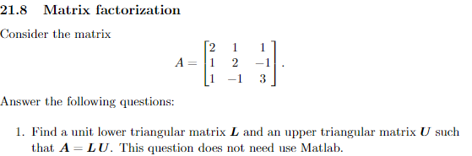

1)

Giving:

2) Having the LU-factorization, this is quite easy:



$$D=\left(\begin{matrix}2 & 0 & 0 \\ 0 & 3/2 & 0 \\ 0 & 0 & 1\end{matrix}\right)$$

$$A=LDL^{T}=\left(\begin{matrix}1 & 0 & 0 \\ 1/2 & 1 & 0 \\ 1/2 & -1 & 1\end{matrix}\right)\left(\begin{matrix}2 & 0 & 0 \\ 0 & 3/2 & 0 \\ 0 & 0 & 1\end{matrix}\right){\left(\begin{matrix}1 & 0 & 0 \\ \frac{1}{2} & 1 & 0 \\ \frac{1}{2} & -1 & 1\end{matrix}\right)}^{T}=\left(\begin{matrix}2 & 1 & 1 \\ 1 & 2 & -1 \\ 1 & -1 & 3\end{matrix}\right)$$

Samme omgang piss om sidst, blot hvor du starter med en unitary diagonal i U.

Ender med at blive:

$$L=\left(\begin{matrix}2 & 0 & 0 \\ 1 & \frac{3}{2} & 0 \\ 1 & -\frac{3}{2} & 1\end{matrix}\right), U=\left(\begin{matrix}1 & \frac{1}{2} & \frac{1}{2} \\ 0 & 1 & -1 \\ 0 & 0 & 1\end{matrix}\right)$$

Et smartere træk havde været at bemærke, at $A$ er en symmetrisk matrix, hvorved at $A=A^{T}={\left(LU\right)}^{T}=U^{T}L^{T}=\tilde{L}\tilde{U}$. Thus I can just use earlier result.



**1. Finding all derivatives: $$x^{'}=t+x \\ x^{''}=1+x^{'} \\ x^{'''}=x^{''} \\ {x^{'''}}^{'}=x'''$$**

Thus, finding:

$$x\left(0\right)=1 \\ x^{'}\left(0\right)=0+1=1 \\ x^{''}\left(0\right)=1+1=2 \\ x^{'''}\left(0\right)=x^{''}\left(0\right)=2 \\ x^{''''}\left(0\right)=x^{'''}\left(0\right)=2$$

**Order 1: Eulers method $$x\left(t+h\right)=x\left(t\right)+hx^{'}\left(t\right)$$**

With initial-condition: $$x\left(0+\frac{1}{2}\right)=1+\frac{1}{2}1=\frac{3}{2}$$

Order 2:

$$x\left(t+h\right)=x\left(t\right)+hx^{'}\left(t\right)+\frac{1}{2!}h^{2}x''(t)$$

With initial-condition: $$x\left(0+\frac{1}{2}\right)=\frac{3}{2}+\frac{1}{2}{\left(\frac{1}{2}\right)}^{2}⋅2=\frac{3}{2}+\frac{1}{4}=\frac{7}{4}$$

Order 3: $$x\left(t+h\right)=x\left(t\right)+hx^{'}\left(t\right)+\frac{1}{2!}h^{2}x^{''}\left(t\right)+\frac{1}{3!}h^{3}x^{'''}\left(t\right)=\frac{7}{4}+\frac{1}{6}{\left(\frac{1}{2}\right)}^{3}2≈1.792$$

Order 4:

$$x\left(t+h\right)=1.792+\frac{1}{4!}h^{4}x^{''''}\left(0\right)=1.792+\frac{1}{4!}{\left(\frac{1}{2}\right)}^{4}2=1.792+\frac{1}{12}\left(\frac{1}{16}\right)=1.796875$$

7.1.13)   
Suppose that a diffeq is solved numerically on interval a,b and the local truncation error is ch^p. Show that if all truncation errors have the same sign (worst possible case), then the total truncation error is (b-a)ch^(p-1).

We know, that the local truncation is

$$ch^{p}$$

And we have $n$ steps between $[a,b]$. Thus, we will have to multiply by $n$:

$$nch^{p}$$

We can do some mathemagic and expand the power factor:

$$nch^{p}=nhch^{(p-1)}=n⋅\frac{b-a}{n}ch^{p-1}=\left(b-a\right)ch^{p-1}$$

7.1.9)   
Consider the problem x’=x. If the initial condition is x(0)=c, then the solution is x(t)=c*exp(t). If a roundoff error of epsilon occurs in reading the value of c into the computer, what effect is there on the solution at the point t = 10? At t=20? Do the same for x’=-x

The absolute error will look like:

$$x_{err}\left(t\right)=\left(c+ϵ\right)e^{t}-ce^{t}=ϵe^{t}$$

Thus, the accumulation will result in errors:

$$x_{err}\left(10\right)=ϵe^{10} \\ x_{err}\left(20\right)=ϵe^{20}$$

Thus they increase as a power of $t$. The relative error though:

$$\frac{x_{err}}{x}=\frac{ϵe^{t}}{ce^{t}}=\frac{ϵ}{c}$$

Is a constant <3

In the other case, we have the solution $ce^{-t}$:

$$x_{err}\left(t\right)=\left(c+ϵ\right)e^{-t}-ce^{-t}=ϵe^{-t}$$

Thus, the error here actually decreases as a power:

$$x_{err}\left(10\right)=ϵe^{-10} \\ x_{err}\left(20\right)=ϵe^{-20}$$

But the relative error again is the same.

function [t,x] = MyTaylorOrder2(diffeq1,diffeq2,tspan,x0,n)

b = tspan(2);

a = tspan(1);

h = (b-a)/n;

x = zeros(1,n+1);

x(1,1) = x0;

t = (linspace(a,b,n+1));

for i=1:n

dval1 = diffeq1(t(i),x(1,i));

dval2 = diffeq2(t(i),x(1,i));

x(1,i+1) = x(1,i)+h*(dval1+(1/2)*h*dval2);

end

end

This boy does well.   
Shoots a bit under the analytical solution, but is very close.

Is called by using:

X1 = @(t,x)t+x;

X2 = @(t,x)1+t+x;

n = 1;

t = [0,1/2];

x0 = 1;

[tvals,xvals] = MyTaylorOrder2(X1,X2,t,x0,n)

Thus, we need to know both derivatives for using this method, ie. 1 differentiation before starting and two function evaluations in every iteration.

So for each doubling of $n$, we expect the global error to be divided by $2^{2}$. Lets have a look:

holder = err_abs/(2^2)

holder =

0.00084415

0.00021608

5.4658e-05

1.3745e-05

3.4464e-06

It almost fits perfectly. Also if you plot it it is beautiful.

X1 = @(t,x)t+x;

X2 = @(t,x)1+t+x;

n = [16,32,64,128,256,512];

t = [0,1];

x0 = 1;

error_holder = zeros(numel(n),1);

for i=1:numel(n)

[tvals,xvals] = MyTaylorOrder2(X1,X2,t,x0,n(i));

error_holder(i) = xvals(end);

end

fanalytical = -2+2*exp(1);

err_abs = abs(fanalytical-error_holder);

expected_reduction = err_abs/(2^2);

expected_reduction_matrix = [n(2:end);expected_reduction(1:end-1)']

semilogy(n,err_abs)

hold on

semilogy(n(2:end),expected_reduction(1:end-1))

legend('absolute error','expected error reduction')



It seems the relative error is quite constant, as expected. But if one looks closely, we observe a small linear trend. As expected, the absolute error increases as a function of $e^{t}$ (that is why it is linear in semiology).   
The growing relative error must be caused by a combination of local truncation and rounding.



3) with n=10000



We see that the error acts in the same way (the curves have the EXACT same shape). We see that the rounding introduced in the relative error has been minimized a bit. Also, the absolute error grows less quickly. This also explains the vertical translation of the error-functions between the two cases.

1) function becomes:

function [t,x] = MyRK4(dxdt,tspan,x0,n)

a = tspan(1);

b = tspan(2);

h = (b-a)/n;

%%x = zeros(1,n+1);

x = x0;

%%t = zeros(1,n+1);

hhalve = h/2;

x = zeros(1,n+1);

t = linspace(a,b,n+1);

x(1,1) = x0;

for i=1:n

K1 = h*dxdt(t(i),x(1,i));

K2 = h*dxdt(t(i)+hhalve,x(1,i)+(1/2)*K1);

K3 = h*dxdt(t(i)+hhalve,x(1,i)+(1/2)*K2);

K4 = h*dxdt(t(i)+h,x(1,i)+K3);

x(1,i+1) = x(1,i) + (1/6)*(K1+2*K2+2*K3+K4);

end

2)   
tspan = [0,1];

dxdt = @(t,x)t+x;

x0 = 1;

fanalytical = @(t)-t-1+2*exp(t);

n = 2.^[4:9];

teo = fanalytical(tspan(2));

error_holder = zeros(3,numel(n));

for i = 1:numel(n)

[t_rk4,x_rk4] = MyRK4(dxdt,tspan,x0,n(i));

[t_heun,x_heun] = MyHeun(dxdt,tspan,x0,n(i));

[t_euler,x_euler] = MyEuler(dxdt,tspan,x0,n(i));

error_holder(1,i) = abs(teo-x_rk4(end));

error_holder(2,i) = abs(teo-x_heun(end));

error_holder(3,i) = abs(teo-x_euler(end));

end

semilogy(n,error_holder)

legend('rk4','heun','euler')

xlabel('number of steps n')

ylabel('log(abs(err))')

figure(2)

loglog(n,error_holder)

%%convergence for rk_4: check if following gives appx constant

disp('convergence of RK4\n')

error_holder(1,:).*n.^4

disp('convergence of heun\n')

error_holder(2,:).*n.^2

disp('convergence of euler\n')

error_holder(3,:).*n.^1

3)

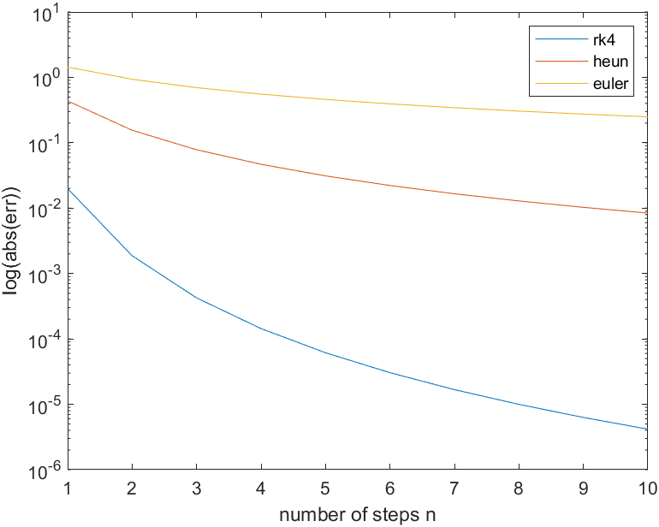

For checking convergence, you just check if following is constant:

$$err⋅n^{α}=c$$

So if it gives a constant, you have that type of convergence. Also, the error fullfills $cn^{α}=err$. Thus, after you have found the convergence, you can say what the error is appx.   
You find that the convergence for euler is $\frac{1}{n}$, heun $\frac{1}{n^{2}}$ and RK4 $\frac{1}{n^{4}}$.

By running the script you get the appx value of .

Here is an initial-value problemthat has two solutions: $x^{'}=x^{1/3}$, $x\left(0\right)=0$. Verify that the two solutions are x1(t)=0 and x2(t) = (t*2/3)^(3/2) for t>=0. What happens if you use Taylor series method?

To verify, I just put in the solution.   
Case 1: $$x^{'}=x^{1/3} \\ →{\left(0\right)}^{'}={\left(0\right)}^{1/3}$$

Which obviously is true and fullfills $x\left(0\right)=0$.   
Case 2:

$$\frac{d}{dt}{\left(\frac{2}{3}⋅t\right)}^{3/2}={\left(\frac{2}{3}\right)}^{3/2}\frac{d}{dt}t^{3/2}={\left(\frac{2}{3}\right)}^{3/2}\frac{3}{2}t^{1/2}={\left(\frac{2}{3}\right)}^{1/2}\sqrt{t}$$

Now, we check if this is the same as $x^{1/3}$:

$${\left({\left(\frac{2}{3}⋅t\right)}^{\frac{3}{2}}\right)}^{\frac{1}{3}}={\left(\frac{2}{3}⋅t\right)}^{\frac{1}{2}}=\sqrt{\frac{2}{3}t}$$

Taking $x\left(0\right)=0$ also seems true, so the two functions must be a solution.

If one were to apply the taylor series method of degree 2:

With

**(MULTIVARIATE CHAIN RULE)**

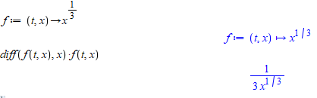

We would get:

$$x\left(0+h\right)=0+h⋅0^{\frac{1}{3}}+\frac{1}{2}h^{2}⋅\frac{1}{3⋅0^{1/3}}$$

Which is undefined. **Thus, Taylors method would fail.**

If one used RK4:

$$x\left(0+h\right)=x\left(0\right)+\frac{1}{6}\left(K_{1}+2K_{2}+2K_{3}+K_{4}\right)$$

$$K_{1}=hf\left(t,x\right)=hf\left(0,0\right)=0 \\ K_{2}=hf\left(t+\frac{1}{2}h,x+\frac{1}{2}K_{1}\right)=hf\left(\frac{1}{2}h,0\right)=0$$

$$K_{3}=hf\left(t+\frac{1}{2}h,x+\frac{1}{2}K_{2}\right)=hf\left(\frac{1}{2}h,0\right)=0$$

$$K_{4}=hf\left(t+h,x+K_{3}\right)=hf\left(h,0\right)=0$$

Thus we end up with:

$$x\left(0+h\right)=x\left(0\right)+\frac{1}{6}\left(0+0+0+0\right)=0$$

Ie RK4 will not fail, but find the zero-solution.



Thus, the solution to this IVP is:





$$x\left(t\right)=\frac{1}{5}e^{-t}\cos{t}-\frac{2}{5}e^{-t}\sin{t}+\frac{3}{5}\sin{t}-\frac{1}{5}\cos{t} \\ y\left(t\right)=-\frac{1}{5}e^{-t}\sin{t}-\frac{2}{5}e^{-t}\cos{t}+\frac{2}{5}\cos{t}-\frac{1}{5}sin⁡t$$

$$F^{'}\left(X\right)=\left(\begin{aligned}-x\left(t\right)+y\left(t\right)+sin⁡(t) \\ -x\left(t\right)-y(t)\end{aligned}\right)$$

function [dF] = odefun(t,x)

dF = [-x(1)+x(2)+sin(t);-x(1)-x(2)];

end

It knows how many diffeqs there are from the size of the inputvector x0.



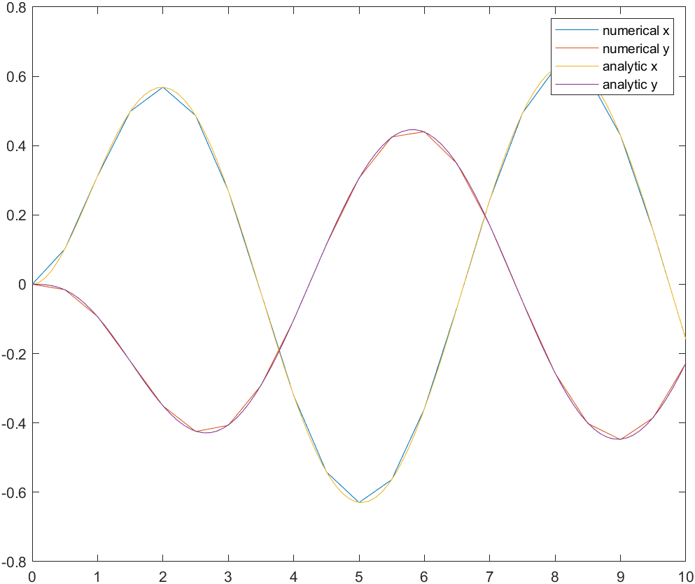





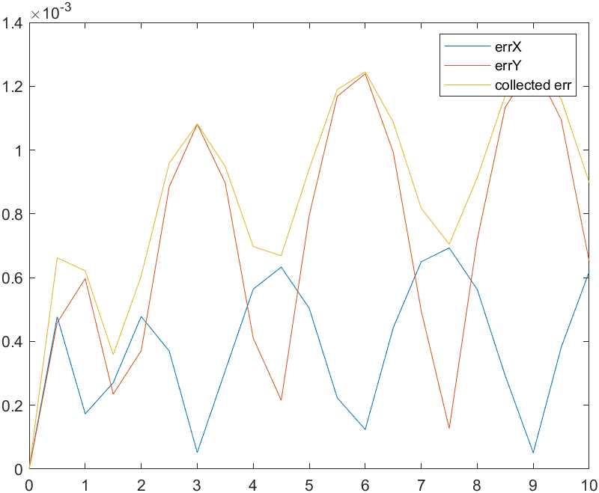

The errors are quite small. I think this is definitely satisfactory.



The crash-test gives huge errors. This is because we are effectively undersampling, and the functions change quickly compared to the samplerate.

We get satisfying results using appx 150 sample-points. We have this many periods

$$NT_{0}=\frac{100}{2π}=\frac{50}{π}$$

And sample $150$ times during these periods, giving us

$\frac{150}{\frac{50}{π}}=9.38$ times per period of .

154 successful steps = 154 iterations. The accuracy is quite bad. This is probably because we did not specify a tolerance range (which we could do). Ode45 is practical because we don’t need to know beforehand how many n we need for a nice precision.

How would a program be used to solve:

$$x^{'''}=t+x+2x^{'}+3x^{''} \\ x\left(1\right)=3,x^{'}\left(1\right)=-7,x^{''}\left(1\right)=4$$

We would linearize by introducing new variables. This will be the dictionary for the problem:

|  |  |  |  |
| --- | --- | --- | --- |
| Old variable | New variable | Initial Value | Differential equation |
| $$x$$ | $$x_{1}$$ | 3 | $$x_{1}^{'}=x_{2}$$ |
| $$x'$$ | $$x_{2}$$ | -7 | $$x_{2}^{'}=x_{3}$$ |
| $$x''$$ | $$x_{3}$$ | 4 | $$x_{3}^{'}=x^{'''}=t+x_{1}+2x_{2}+3x_{3}$$ |

Thus, we have a first order system:

$$X^{'}=\left(\begin{aligned}x_{2} \\ x_{3} \\ t+x_{1}+2x_{2}+3x_{3}\end{aligned}\right)$$

**With initial-conditions:**

$$X\left(1\right)=\left(\begin{aligned}3 \\ -7 \\ 4\end{aligned}\right)$$

The right hand side thus would simply be:

$$odefun(t,X)=[X\left(2\right);X\left(3\right);t+X\left(1\right)+2X\left(2\right)+3X\left(3\right)]$$

How would the system be solved if we did not have an initial-condition for $x''$ but only for $x'''$?

Well, in that case it is not a standard IVP. But we can find our unknown using the boundary-conditions:

$$x^{'''}(t)=t+x+2x^{'}+3x''$$

With initialconditions:

$$x^{'''}\left(1\right)=0=1+3+2\left(-7\right)+3x''$$

$$⟺x^{''}\left(0\right)=\frac{14-4}{3}=\frac{10}{3}$$

Which thus would give:

$$X\left(1\right)=\left(\begin{aligned}3 \\ -7 \\ 10/3\end{aligned}\right)$$

and we can use the same dictionary as above.

Starter med at omskrive systemet med følgende dictionary:

$$⟺y^{''}=\left(y-x-y^{'}\right)⋅\frac{1}{7}$$

|  |  |  |  |
| --- | --- | --- | --- |
| Old variable | New variable | Initial Value | Differential equation |
| $$y$$ | $$z_{1}$$ | 5 | $$z_{1}^{'}=z_{2}$$ |
| $$y'$$ | $$z_{2}$$ | -0.8 / -0.9 | $$z_{2}^{'}=y^{''}=\left(z_{1}-x-z_{2}\right)⋅\frac{1}{7}$$ |

Implementeres I matlab:

y_guess_1 = [5;-0.8];

y_guess_2 = [5;-0.9];

tspan = [0,20];

[x_shot_1,y_shot_1] = ode45(@odefun,tspan,y_guess_1);

[x_shot_2,y_shot_2] = ode45(@odefun,tspan,y_guess_2);

endVals = [y_shot_1(end,:),y_shot_2(end,:)] %%first part of solution is gonna be end-point of y (trajectory), second part is gonna be end-point of y' (velocity)

endpoints = [endVals(:,1:2:3)] %%only take trajectory-solutions

plot(x_shot_1,y_shot_1(:,1))

hold on

plot(x_shot_1,y_shot_2(:,1))

legend('shot 1','shot 2')

function [X] = odefun(x,y)

[X] = [y(2);(y(1)-x-y(2))*1/7];

end

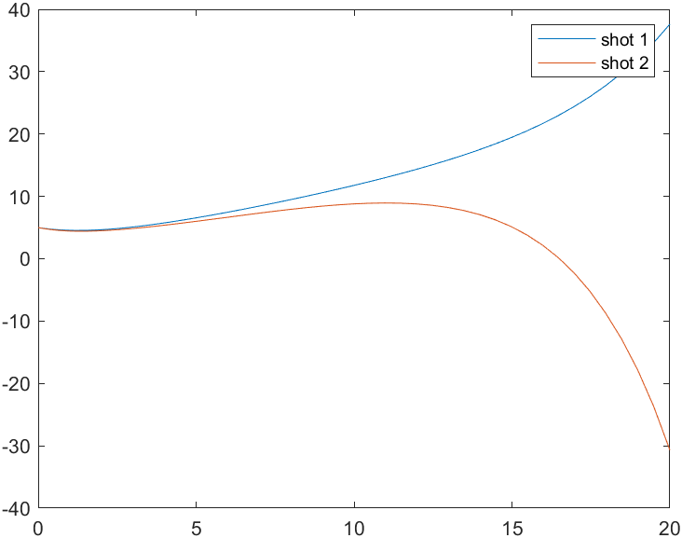

$z$ skal altså ligge et sted imellem $-0.8$ og $-0.9$. Vi har endepunkts-værdispændet $[-30.697;37.625]$ med vores to gæt.



guess_interval = linspace(-0.9,-0.8,1000);

phi = zeros(numel(guess_interval),1); %for efficiency

for i=1:numel(guess_interval)

[x_tmp,y_tmp] = ode45(@odefun,tspan,[5;guess_interval(i)]);

phi(i) = y_tmp(end,1);

end

figure(2)

plot(guess_interval,phi)

xlabel('dy/dx(0)=z')

ylabel('y(20)=\phi(z)')

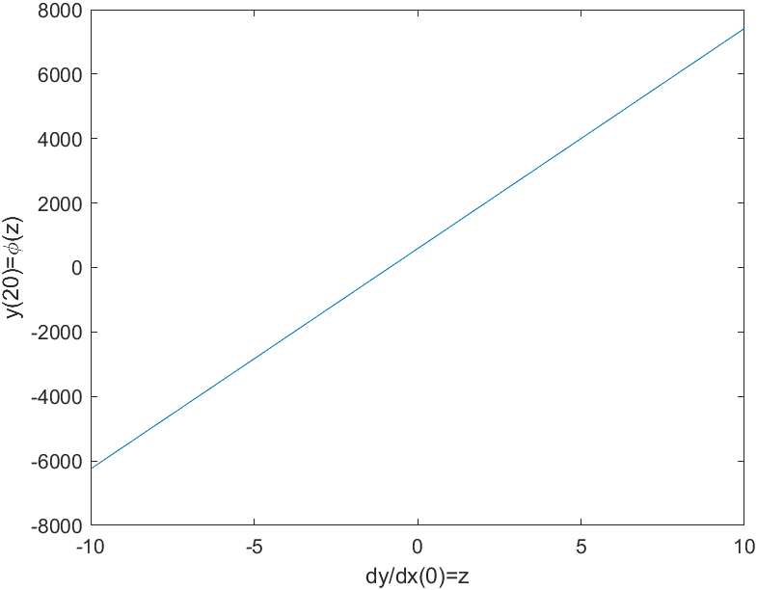

It is a linear function. Thus, we would use the secant method to find the root. We would only need one iteration.

We use the secant-method with initial-point:

$$z_{r}=z_{1}+\frac{\left(z_{2}-z_{1}\right)}{\left(ϕ\left(z_{2}\right)-ϕ\left(z_{1}\right)\right)}(8-ϕ(z_{1})$$

Which gives us the root-value $z=-0.8434$

5)

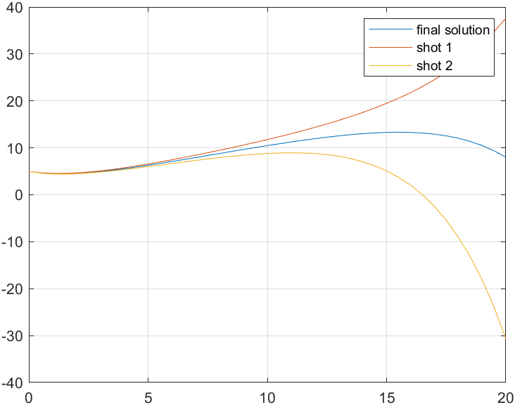

Tada. Vi opfylder boundary-value problemet.

A1:

(as it is a second order runge kutta)

A2)   
Globally, we multiply by n:

Six dif.eqs.



RK4 has a local truncation error of $O(ch^{5})$. Globally, this results in a truncation error of $O\left(ch^{5}n\right)=O(ch^{4})$.

Thus, we know: $$σ=ch^{4}=c{\left(\frac{1}{2}\right)}^{4}={10}^{-3}$$

$$→c=\frac{2}{125}$$

And thus:

Den her laver du lige i morgen

Made by hand, look at block.

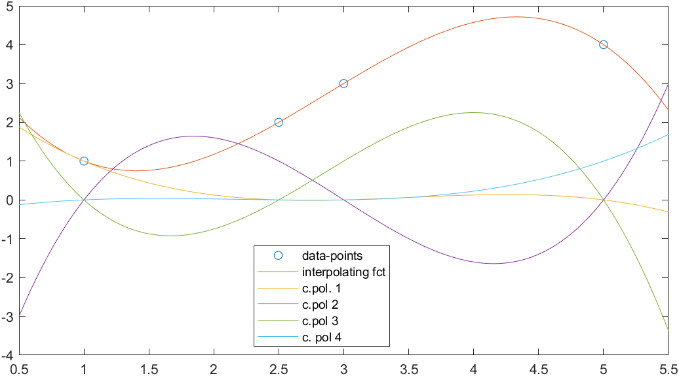

Seems very nice.

I did like this:



1)   
Using the second interpolation error theorem, the upper bound of the polynomial error is given by:

$$\left|f\left(x\right)-p(x)\right|≤\frac{1}{4\left(n+1\right)}Mh^{n+1}$$

With $h=\frac{b-a}{n}$, and $\left|f^{\left(n+1\right)}\left(x\right)\right|≤M$

Thus, we derive the upper bound for the derivative (we have a very nice function): $$M≥|e^{x}|$$

And we have $$\left|f\left(x\right)-p(x)\right|≤\frac{1}{4\left(12+1\right)}\left|e^{x}\right|{\left(\frac{3-\left(-1\right)}{12}\right)}^{12+1}=1.21⋅{10}^{-8}\left|e^{x}\right|=1.21⋅{10}^{-8}\left|e^{3}\right|=2.42⋅{10}^{-7}$$

2).

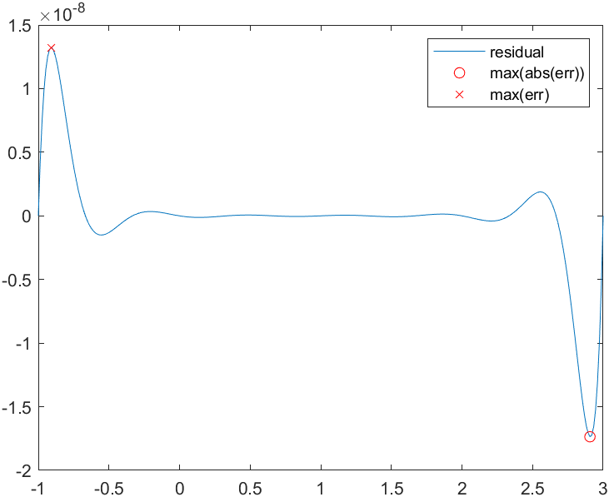

The maximal error is $1.32⋅{10}^{-8}$ and occurs at

3)   
The maximal absolute error is at $x=2.91$ and has size $1.74⋅{10}^{-8}$. Thus, it is larger than the earlier found error. Both errors are smaller than the upper bound.







We see, that the approximation is best at appx n=7. Larger degree polynomials introduce error-oscillations.

When we make the interval way smaller:

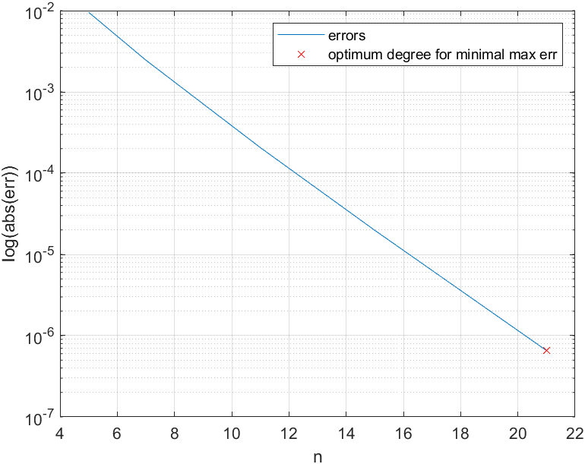

It seems the errors behaves nicely when increasing the order of the polynomial.   
But why? It has the x-axis as an asymptote. When only using -0.9..0.9 we do not need care about the asymptoticity. But when using -5..5 we do need to model an asymptote (linearity), and this linearity can not be modelled with high-order oscillating polynomials.

We see, that in general the error are biggest in the “tails” of the functions, close to the edges of the interval. This is called Runges phenomenon.

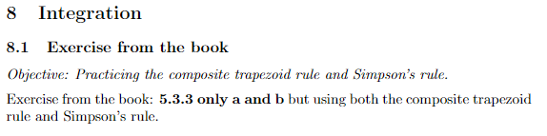

Made on paper

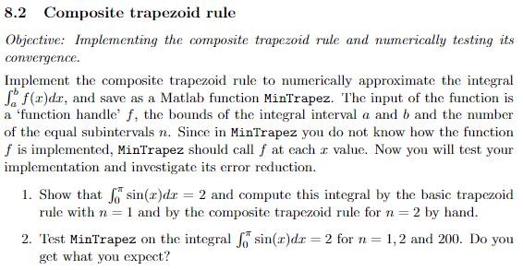

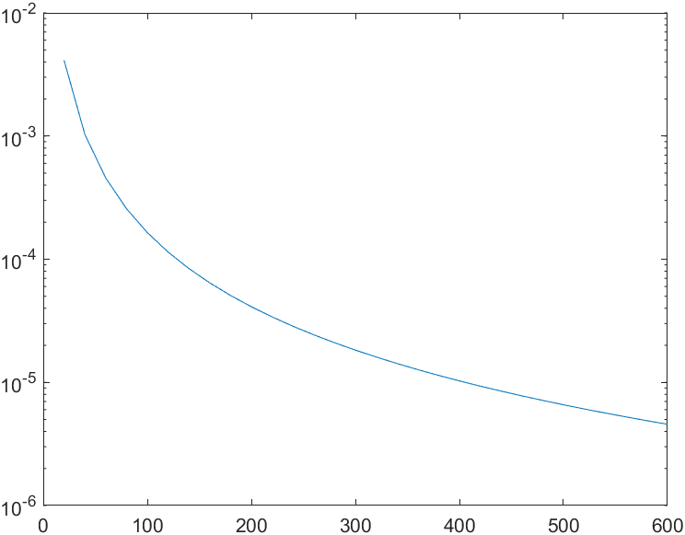

The error seems to be approximately linear after $n=400$.

4)

%%Q4 data-fitting this boy

m = n(15:end);

Lerr = log(err(15:end));

A = [-log(m'),ones(numel(m),1)];

c = (A'*A)\(A'*Lerr)

Gives , .

We know:

$$I-T=-\frac{1}{12}\left(b-a\right)h^{2}f^{''}\left(ζ\right)=-\frac{1}{12}\left(b-a\right)h^{2}|-sin⁡(x)|≤\frac{1}{12}\left(b-a\right)h^{2}\sin\left(\frac{π}{2}\right)=\frac{1}{12}\left(b-a\right)h^{2}$$

Which using our boundaries yields:

$$\frac{1}{12}\left(π-0\right){\left(\frac{π-0}{n}\right)}^{2}=\frac{π}{12}{\left(\frac{π}{n}\right)}^{2}$$

As requested.   
Solving the inequality we find that we need to bring at least $509$ terms.

Testing with the given equation (1):

$$β-α⋅\log\left(n\right)≤{log⁡(10}^{-5}) \\ →n≥406$$

Which is not the same, but kinda close to (remember, we found an UPPER bound ie worst-case).

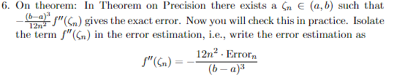



Den dobbelt-afledte er $-sin⁡(x)$. Derfor skal udtrykket have værdier, som er imellem $-\sin{(0})…-sin⁡(π)=[-1;0]$. Når man plotter det, er det heldigvis tilfældet. Endvidere kan vi skrive gennemsnittet:

Vi kan også bestemme gennemsnitsværdien:

$$\overline{f^{''}}=\frac{f''(b)-f''(a)}{b-a}= \frac{1}{π-0}\int_{0}^{π}{-sin⁡(x)}dx=-\frac{2}{π}$$

Som er, hvad funktionen konvergerer imod.

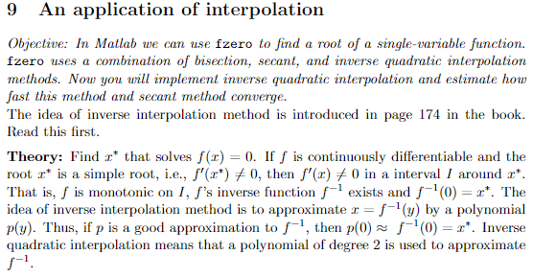

Du mangler invers interpolation

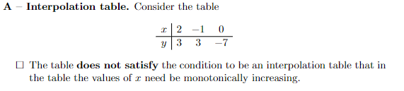

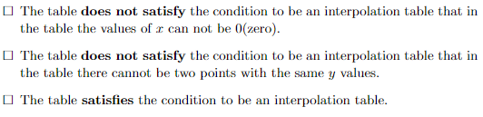

Last one.

Basis-functions are:



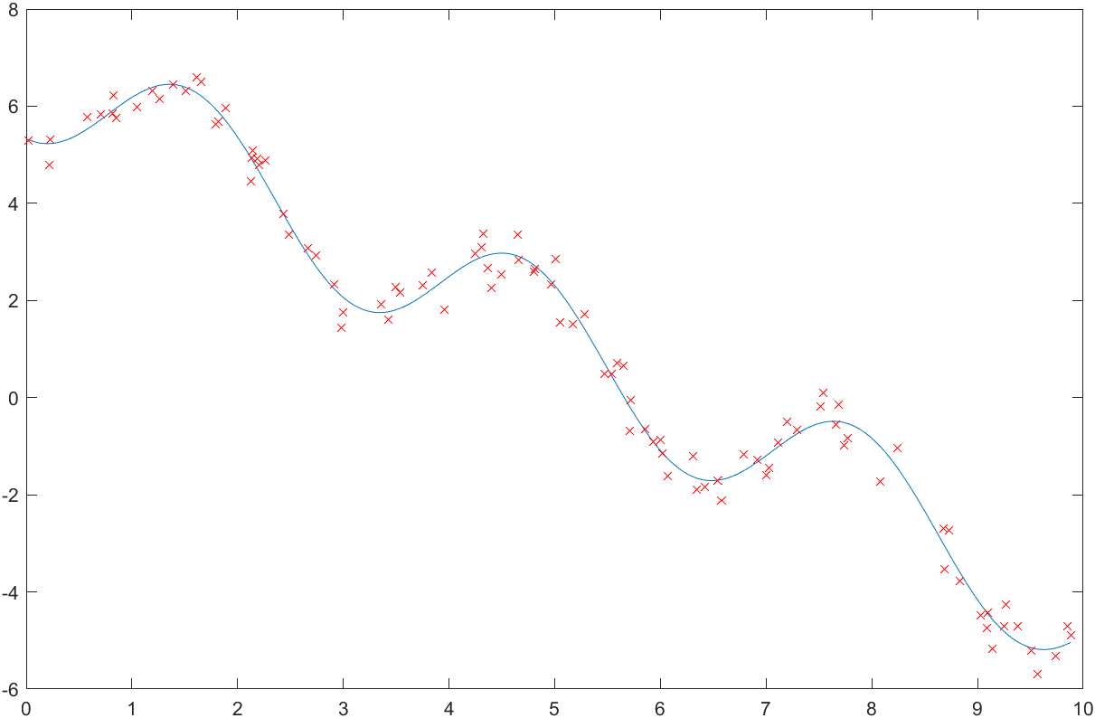

Three requirements for the basis-functions:

1. Linearly independent

2. Appropriate for the given problem

3. need to be well-conditioned for numerical work

All basis-functions are linearly independent.   
Are they appropriate for the given problem?

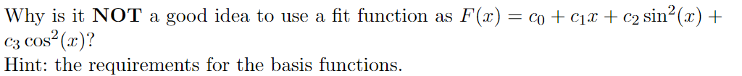

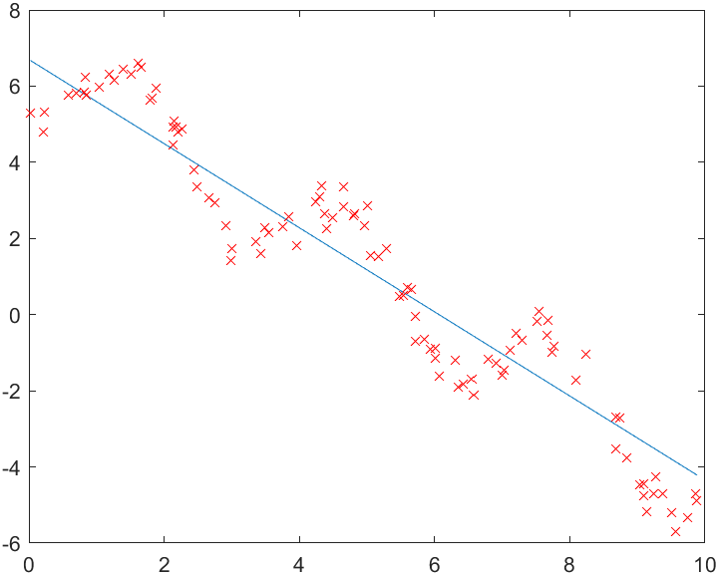

Obviously they do not describe the periodicity well. We know that $\sin^{2}{(x)}+\cos^{2}{(x)}=1$, which we just scale a bit funnily. Thus we loose the oscillations.

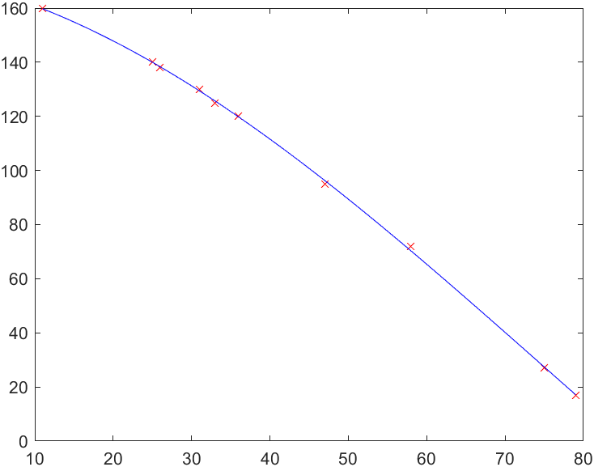

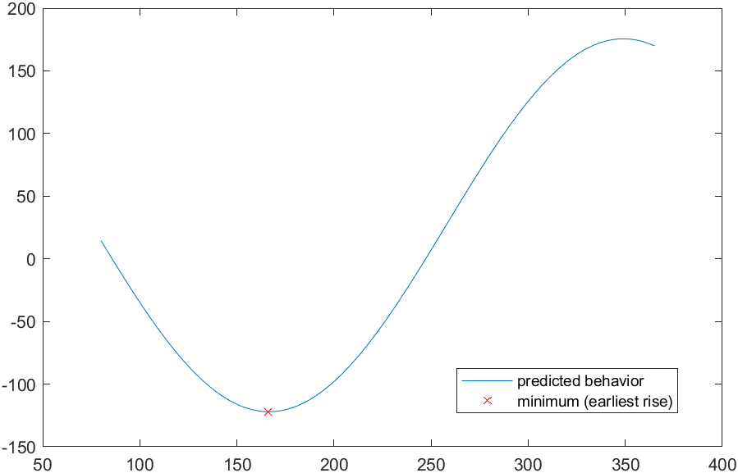

The earliest rise will thus be in summer on the 166th day after jan 1st at around 6am-122min = 3.58am.

Normal equation is:

$$\left(A^{T}A\right)c=A^{T}y$$

with

$$A=\left(\begin{matrix}sin⁡(-π) & cos⁡(-π) & 1 \\ sin⁡(-\frac{π}{2}) & \cos\left(-\frac{π}{2}\right) & 1 \\ sin⁡(0) & \cos{0} & 1 \\ \sin\left(\frac{π}{2}\right) & \cos\left(\frac{π}{2}\right) & 1 \\ sin⁡(π) & \sin{(π)} & 1\end{matrix}\right)$$

* which gives:

$${(A}^{T}A)\left(\begin{aligned}a \\ b \\ c\end{aligned}\right)=A^{T}\left(\begin{aligned}-1 \\ 0 \\ 1 \\ 2 \\ 1\end{aligned}\right)$$

The normal equation for calculating the constants is:

$$\left(\begin{aligned}a \\ b \\ c\end{aligned}\right)={\left(A^{T}A\right)}^{-1}A^{T}\left(\begin{aligned}-1 \\ 0 \\ 1 \\ 2 \\ 1\end{aligned}\right)$$

The system matrix is $A^{T}A=\left(\begin{matrix}2 & 0 & 0 \\ 0 & 3 & -1 \\ 0 & -1 & 5\end{matrix}\right)$ and the right-hand side is

2)

3)   
Quite bad fit.

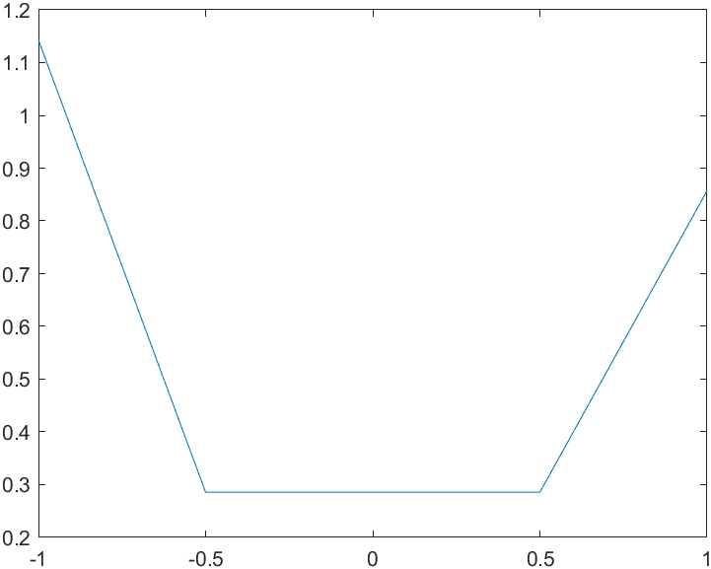

max abs Err:

function [x] = MyNewton(f,df,x0,nmax)

%f is function handle for function

%df is function handle for derivative

%x0 is start-guess

%nmax is number of iterations used

x = ones(nmax+1,1);

x(1) = x0;

for n=1:nmax

fx = f(x(n));

fp = df(x(n));

x(n+1) = x(n)-fx/fp;

end

end

We see that the converge towards root = 1.   
But how do we know if it is quadratic convergence?

We can tell, that the error is falling, and we gain a doubling of significant digits in every iteration after iteration 3. The proper way to tell if we have quadratic convergence is to look at the ratio-table.  
When $\left|\frac{e_{n}}{e_{n-1}^{2}}\right|→c$ we have quadratic convergence. We see that this is the case after a couple of iterations. It converges towards 0.83.

Is this the same as the constant?

It absolutely seems so <3

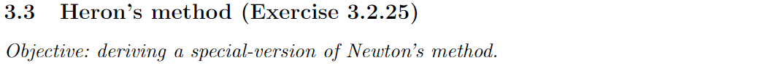

The newton iteration is gonna be:

$$x_{n+1}=x_{n}-\frac{x_{n}^{2}-R}{2x_{n}}=x_{n}-\frac{x_{n}}{2}+\frac{R}{2x_{n}}$$

Subtracting the half of a size is the same as half of the size:

$$x_{n+1}=\frac{x_{n}}{2}+\frac{R}{2x_{n}}=\frac{1}{2}\left(x_{n}+\frac{R}{x_{n}}\right)$$

Tada

f = @(x)x^2-2;

df = @(x)2*x;

nmax = 2;

x0 = 1;

x = MyNewton(f,df,x0,nmax);

while(abs(x(end)-sqrt(2))>eps)

nmax = nmax + 1;

disp("incrementing");

x = MyNewton(f,df,x0,nmax);

end

disp("done :-) ")

sprintf("nmax becomes %d",nmax)

We need at least 5 iterations to get to machine-precision.

Using bisection method:

We have:

$$f\left(1\right)=1-2=-1 \\ f\left(2\right)=4-2=2$$

Multiplied they are <0. We find the midpoint:

$$c=\frac{1}{2}\left(1+2\right)=\frac{3}{2}$$

$$w={\left(\frac{3}{2}\right)}^{2}-2=\frac{1}{4}$$

As $w>0$, we know that the root lies in $[a;c]$, as $-1⋅\frac{1}{4}<0$.   
Iteration 2:

$$c=\frac{1}{2}\left(1+\frac{3}{2}\right)=5/4$$

$$w={\left(\frac{5}{4}\right)}^{2}-2=-\frac{7}{16}$$

Etc.   
We would need

52 iterations.

->

function root = bisection_method(f,a,b,nmax,epsilon)

fa = f(a);

fb = f(b);

if(sign(fa)==sign(fb))

disp("same sign");

return

end

error = b-a;

for n=0:nmax

error = error/2;

c = a+error;

fc = f(c);

if(abs(error)<epsilon)

disp("convergence achieved")

root = c;

return

else

if(sign(fa)~=sign(fc))

b = c;

fb = fc;

else

a = c;

fa = fc;

end

end

end

end

Newton-method in this case does not converge *at all.* This is because we have an unlucky start-guess. It gets stuck in a loop.   
Secant-method converges rather quickly.   
Bisection-method converges, but does so very slowly.

Newton with a good starting guess converges way quicker.

First answer.

x = [-1,0,0.6,1]';

y = [-0.5,0.1,0.3,0.24]';

A = [ones(numel(x),1) x];

c = (A'*A)\(A'*y)

C. Look p. 131 – this is right – but that does not even matter if B is not satisfied. If we start in a flat-spot we never converge at any rate.

To iterationer giver 0.5439.

The two points are almost exactly equally big. Thus, we would have a horizontal secant, and divide by 0 (in practice, we would have underflow as it is not exactly 0).